Rationale:
While it is better to save up to purchase something rather than borrowing money to purchase that same object, sometimes you just don't have a choice. Some purchases are just too important to wait for - you need the car to get to work, you need a place to live, and you often have to pay for an education. As such, there are times that you have to borrow money, paying a greater amount of money back in order to get that item you really need. There are entire industries built around this concept - car finances, credit cards, and mortgage companies all exist and thrive off of its customers borrowing money for that item they really need now. This assignment will explore different types of ways that you could borrow money to purchase a car to help you better understand the mathematics behind debt.

Instructions:
Use the formulas for compound interest and amortizations to help you answer the questions below. As you work through the problems, try to spot the patterns that emerge. Thinking about the work you are doing as you are doing it will help you answer the discussion questions in the final step of this project.

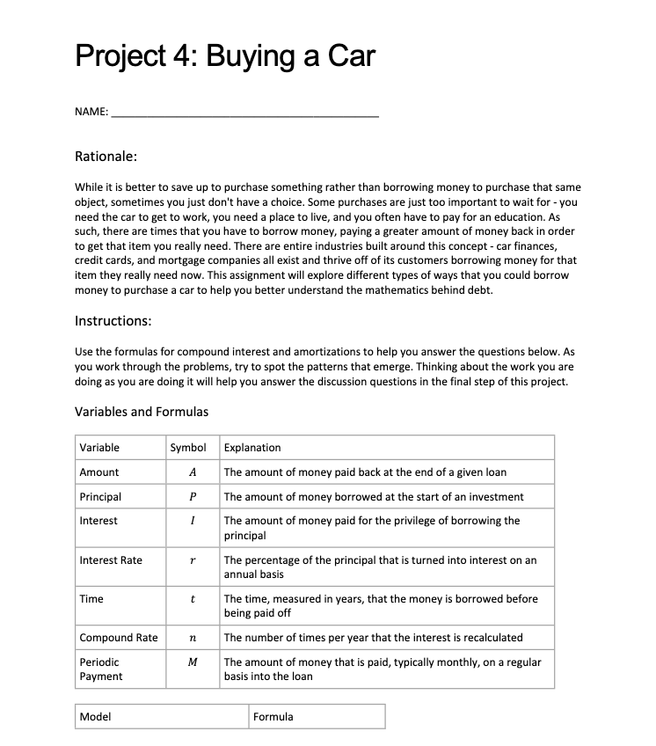
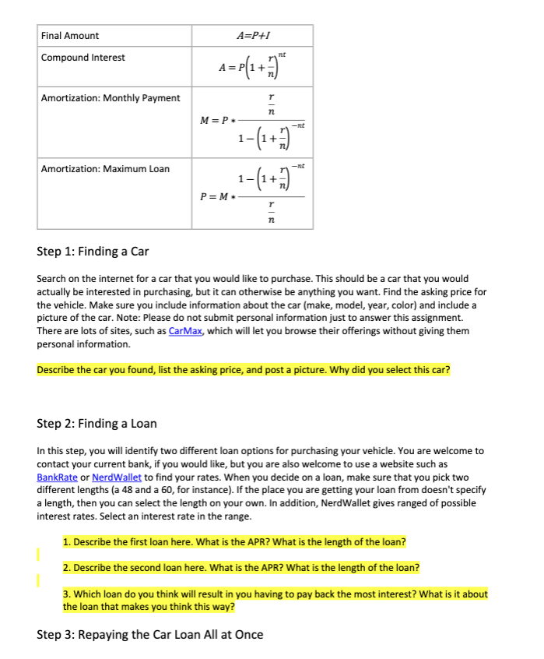
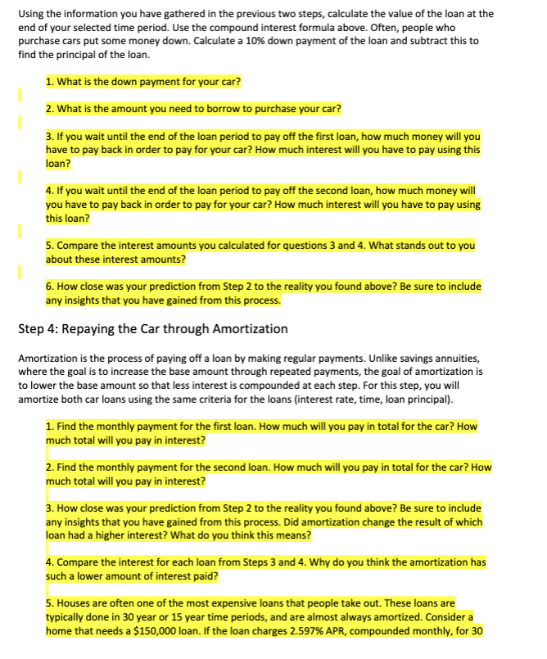

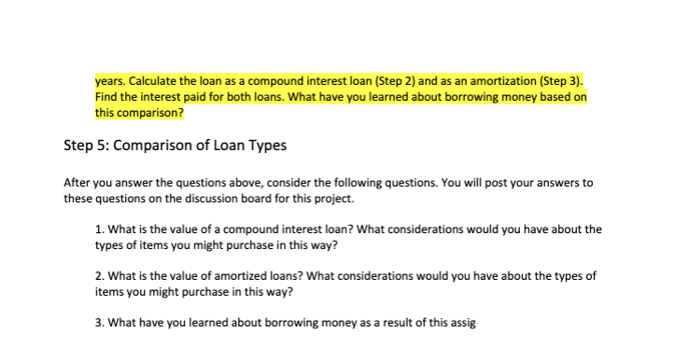

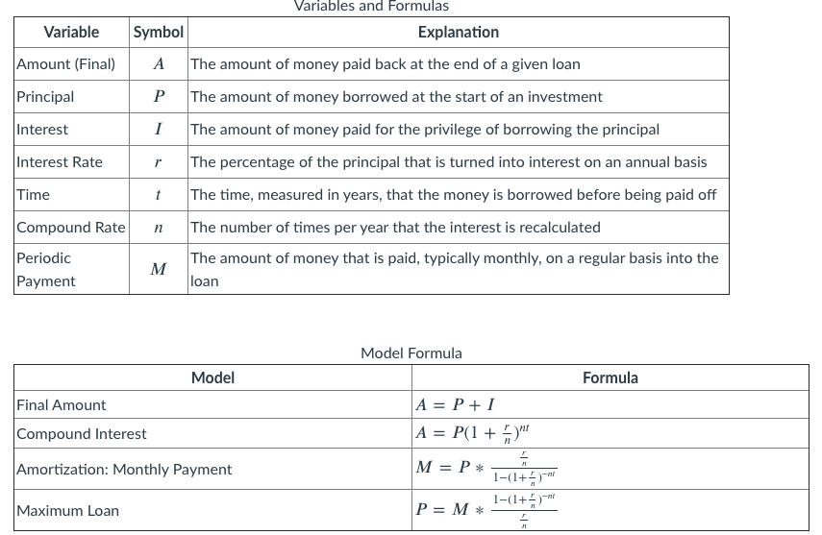

Step 1: Finding a Car
Search on the internet for a car that you would like to purchase. This should be a car that you would actually be interested in purchasing, but it can otherwise be anything you want. Find the asking price for the vehicle. Make sure you include information about the car (make, model, year, color) and include a picture of the car. Note: Please do not submit personal information just to answer this assignment. There are lots of sites, such as CarMax, which will let you browse their offerings without giving them personal information.

Step 2: Finding a Loan
In this step, you will identify two different loan options for purchasing your vehicle. You are welcome to contact your current bank if you would like, but you are also welcome to use a website such as BankRate or NerdWallet to find your rates. When you decide on a loan, make sure that you pick two different lengths (a 48 and a 60, for instance). If the place you are getting your loan from doesn't specify a length, then you can select the length on your own. In addition, NerdWallet gives ranged of possible interest rates. Select an interest rate in the range.

Step 3: Repaying the Car Loan All at Once
Using the information you have gathered in the previous two steps, calculate the value of the loan at the end of your selected time period. Use the compound interest above. Often, people who purchase cars put some money down. Calculate a 10% down payment of the loan, and subtract this to find the principal of the loan.

Step 4: Repaying the Car through Amortization
Amortization is the process of paying off a loan by making regular payments. Unlike savings annuities, where the goal is to increase the base amount through repeated payments, the goal of amortization is to lower the base amount so that less interest is compounded at each step. For this step, you will amortize both car loans using the same criteria for the loans (interest rate, time, loan principal).

Step 5: Comparison of Loan Types

